Creamy Skillet Chicken & Bell Peppers for Two

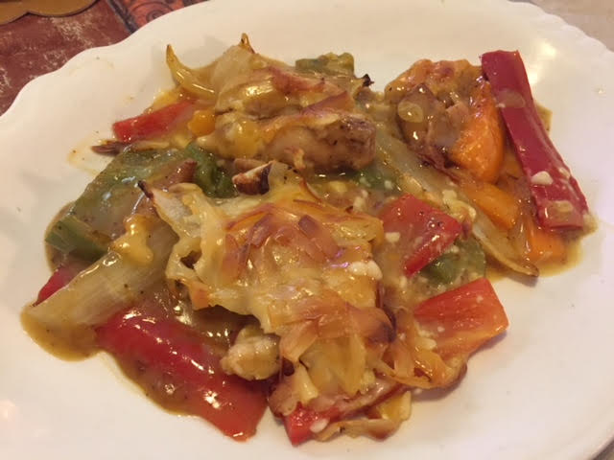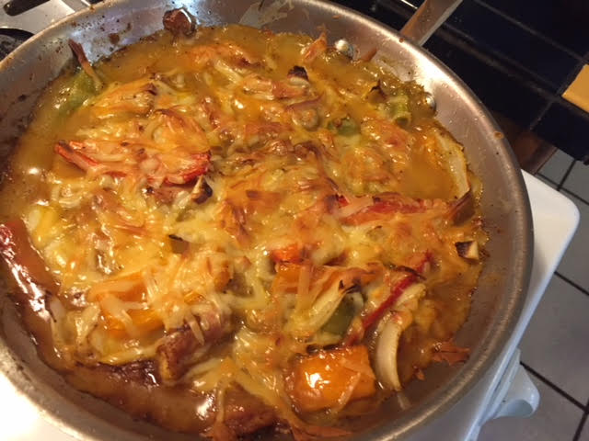

Ingredients:
2 boneless, skinless chicken thighs (about ½ pound), cut into ½“ thick strips (I use kitchen sheers)
¼ teaspoon cumin
¼ teaspoon salt
¼ teaspoon chili powder
¼ teaspoon ground cayenne pepper or milder Creole seasoning
¼ teaspoon poultry seasoning
¼ teaspoon oregano
¼ teaspoon ground, dried (or fresh) thyme
Crushed red-pepper flakes, to taste
½ yellow onion, or a very small one, sliced into strips the same size as the chicken
½ each assorted bell peppers (green, yellow, red), sliced same as the chicken
4 cloves garlic, thinly sliced
1 can cream of chicken soup
½ cup shredded Gruyère, Grand Cru, Doux de Montagne or some other meltable, white French or Swiss cheese
¼ cup white wine (a good kind that you actually drink)
2 tablespoons olive oil

Preparation:
Preheat oven to 350º F. Mix the herbs and spices, then toss with the chicken (I toss it all in a paper bag).

Heat olive oil over med-high heat in an oven-proof skillet and sear chicken until nicely browned, remove from pan, add the peppers, garlic, onions and wine; lightly sauté until starting to soften, making sure to scrape up brown bits from the pan.

Place chicken and their juices back in the pan, add the soup, season with a little salt and ground, black pepper, then stir well. Top with the cheese and bake for 35 – 40 minutes, until the internal temperature of the chicken reaches 175º F. Yum!

