Salami & Cheese Chop-Block Bread (recipe serves 6 – 8)

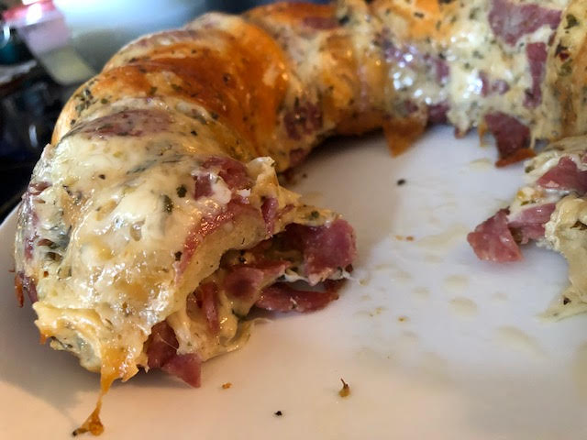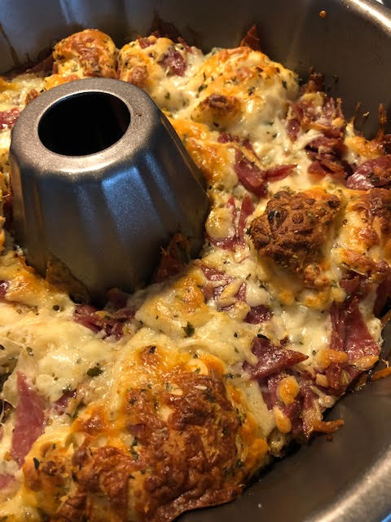

Milwaukee’s Pick N’ Save upscale Metro Markets used to sell a variety of these chop-block breads. Kroger took Pick N’ Save over from the original owner (Roundy’s) and they stopped selling them. The salami and cheese was my favorite, so I figured out how to make it! You can of course add anything else you like to the recipe, like sliced black olives or jalapeño peppers. You can of course also seriously scale back the amount of meat and cheese that I have listed below to make it less greasy and more of an Italian foccacia type of bread.

Ingredients:
1 13 – 14 ounce tube of regular pizza crust dough, cut into small pieces
6 – 8 ounces grated or shredded cheese
6 – 8 ounces hard salami, cut into small pieces
1½ teaspoons dried oregano
½ teaspoon dried basil
1 teaspoon dried parsley
Crushed red-pepper flakes, to taste
¼ teaspoon salt

Preparation:
Preheat oven to 350˚ F. Lightly grease a Bundt pan.

In a large bowl, mix all the ingredients well – mind that the pieces of dough might tend to clump together and may need to be separated by hand in the bowl. Spread evenly in the Bundt pan and bake for 30 minutes, or until the top is crispy and golden brown. Let cool to room temperature before serving.

