Chili-Cheese Hot Dog Bake (recipe makes 4 big chili-cheese dogs)

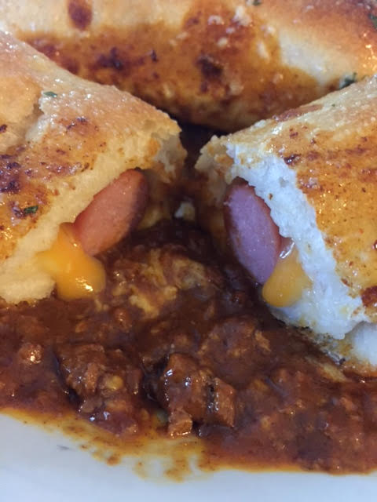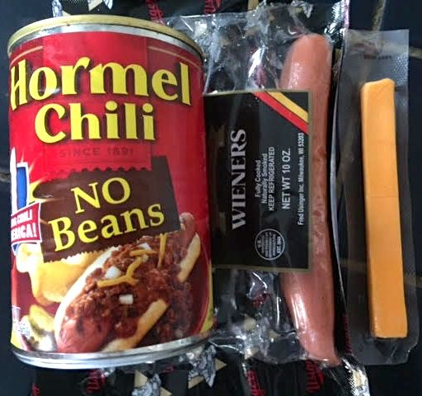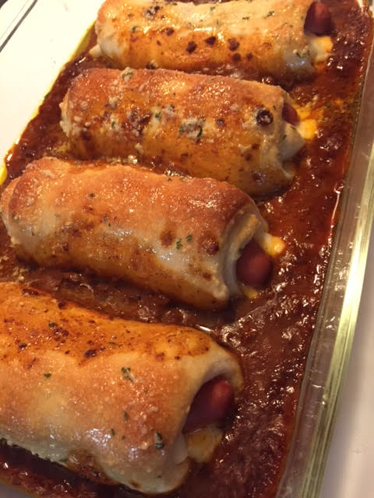

We all have to treat ourselves to something decadent and sick like this once every other blue moon, right!?

Ingredients:
4 hot dogs
4 cheese sticks, any kind you like – Cheddar, Colby, mozzeralla
1 11-ounce tube refrigerated pizza dough (I use Pillsbury brand)
1 15-ounce can chili (I use the kind with no beans)
½ stick (¼ cup) butter, melted
1 teaspoon granulated garlic powder
¼ teaspoon dried parsley

Preparation:
Preheat your oven the 375° F.

Cut the cheese sticks in half lengthwise. Open the tube of dough and roll it out. Slice the dough into 4 equal sheets. Take a hot dog and sandwich it in between the cheese-stick halves. Roll it up in a section of pizza dough.

Place the 4 wrapped cheese-dogs seam-side down in a greased baking dish large enough to accommodate them all. Spoon the canned chili in between the wrapped dogs, then bake them for 20 – 25 minutes, until the dough is golden brown.

While the dogs bake, mix the garlic and parsley with the melted butter. Brush the baked dogs with the butter mixture before serving them plated on some of the chili.

