Cheese Steak Stuffed Bell Peppers for Two

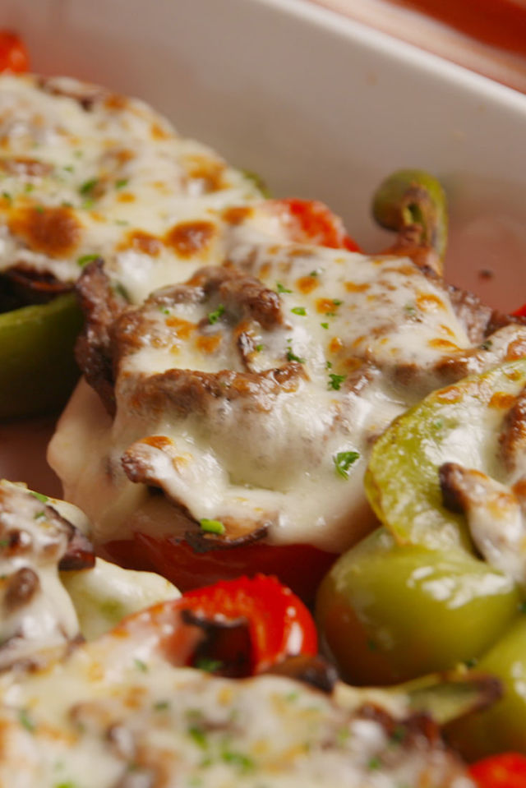

Ingredients:
- 2 bell peppers, halved and seeded with ribs removed (2 halves per serving)
- 12 ounces sirloin steak, thinly sliced (freeze it about 20 minutes first to firm it up)
- 1 small onion, thinly sliced
- 8 ounces crimini (baby portabella) mushrooms, sliced
- Salt, ground black pepper, dried oregano, basil, any fresh herbs on hand
- 8 slices provolone cheese
- Olive or vegetable oil – enough to grease the pan and fry the steak

Preparation:
Preheat oven to 325º F. Place peppers in a large, greased baking dish and bake until tender, 20 minutes.

Meanwhile, in a large skillet over medium-high heat, heat oil. Add steak, season with salt and pepper; sauté about 1 minute per side. Set aside.

Add onions, mushrooms, the dried and any fresh herbs on hand to the skillet and season with salt and pepper. Return steak to skillet and stir to combine.

Add provolone to bottom of peppers and top with steak mixture. Top with another piece of provolone and broil, 3 minutes. Serve hot.

