Banana Pudding – recipe makes 8 servings

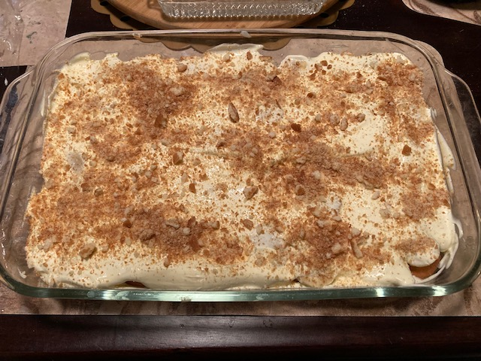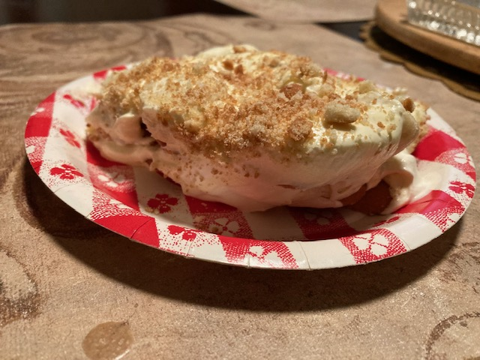

This southern favorite is a super easy and delicious dessert to take to picnics, backyard BBQs, church and family functions. You'll have them begging for this no-cook recipe!

Ingredients:
4 not-so-ripe bananas (but ripe ones will do just fine)
1 large (5.1-ounce) box of instant vanilla or banana pudding
3 cups milk (to make the pudding)
1 8-ounce tub Cool Whip
1 11-ounce box Vanilla Wafers (don’t eat any – you’ll need the whole box!)

Preparation:
Put one layer of cookies on the bottom of an ungreased 13” x 9” casserole dish. Slice 2 of the bananas up into ¼“ rounds and layer on top of cookies.

Follow instructions on pudding box to make the pudding. Fold the whole tub of Cool Whip into the pudding, mixing well.

Pour half of the pudding mixture on top of first layer of cookies and bananas. Put a second layer of cookies and bananas on top of pudding, then pour the rest of pudding mixture on top of second layer, smoothing it out evenly.

Crush up the remaining cookies and sprinkle the crumbs evenly over the top. Refrigerate, covered with cling wrap, about an hour before serving.

If you could some how individually wrap the sloppy slices, I bet this recipe would freeze nicely and make a wonderful frozen dessert!

