Banana Bread

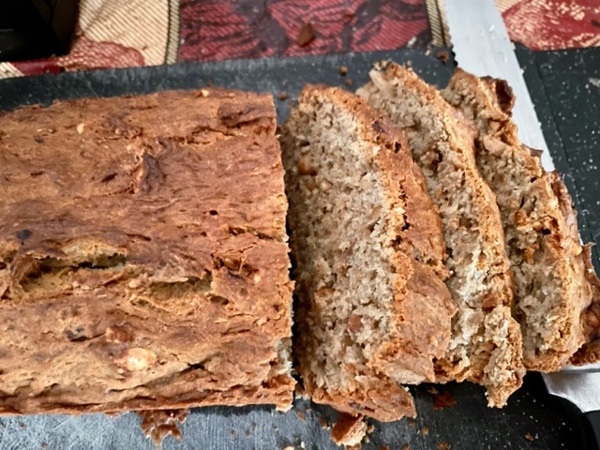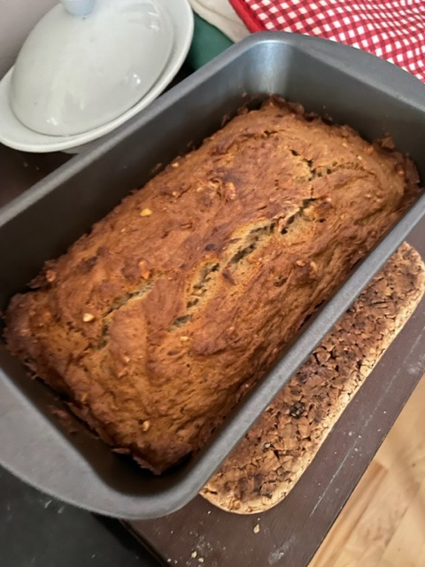

Ingredients:
2 - 3 medium ripe bananas, peeled (about 1¼ - 1½ cups mashed)
1/3 cup (2/3 stick) butter, unsalted, melted
½ teaspoon baking soda (not baking powder)
1/8 teaspoon salt (see note* below)
¾ cup sugar (½ cup if you would like it less sweet, 1 cup if more sweet)
1 large egg, beaten
1 teaspoon vanilla extract
1½ cups all-purpose flour
Chopped walnuts, to taste

Preparation:
Preheat the oven to 350° F., and butter an 8” x 4” loaf pan.

In a mixing bowl, beat the egg, then mash in the ripe bananas with a fork until completely smooth. Stir the melted butter into the mashed bananas.

Mix in the remaining ingredients, combining well.

Pour the batter into your prepared loaf pan. Bake for 1 hour at 350° F., or until a toothpick or wooden skewer inserted into the center comes out clean. A few dry crumbs are okay; streaks of wet batter are not. If the outside of the loaf is browned but the center is still wet, loosely tent the loaf with foil and continue baking until the loaf is fully baked.

Remove from oven and let cool in the pan for a few minutes. Then remove the banana bread from the pan and let cool completely before serving. Slice and serve. (A bread knife helps to make slices that aren't crumbly.)

Wrapped well, the banana bread will keep at room temperature for 4 days. For longer storage, refrigerate the loaf up to 5 days, or freeze it.

*Peanut Butter Banana Bread – a delicious variation!
Follow the recipe, but also mix in ½ cup creamy peanut butter into the batter, leaving some faint streaks of peanut butter in it. Add chopped peanuts instead of walnuts (leave out the 1/8 teaspoon salt if using salted nuts). Some people put chocolate chips in theirs, too.

