Appalachian Meat n ‘Tater Casserole (recipe makes 4 – 6 servings)

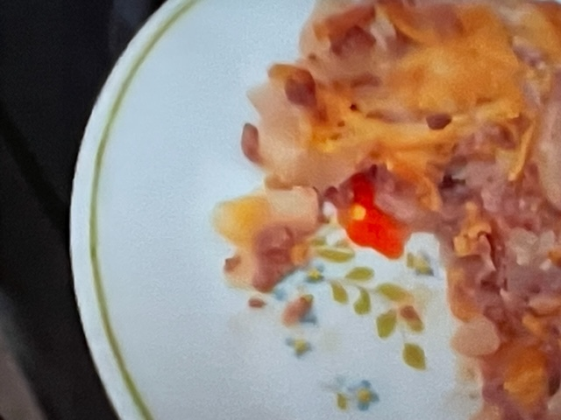

Ingredients:
1 pound ground meat – beef, chicken, deer, whatever you have on hand
4 pounds potatoes, peeled and sliced about a quarter inch thick
1 can of cream of anything soup, plus a can full of milk
1 large onion, chopped
A few cloves garlic, minced
2 cups shredded cheese of your choice (they like to use cheddar)
Salt and ground, black pepper, to taste
1 tablespoon butter, more for greasing a large baking dish
Fresh or dried parsley for garnish (optional)

Preparation:
Preheat oven to Bake at 375°F. Grease a large glass baking dish with butter.

Parboil/cook the potato slices with the butter until tender, then drain. I just put them in a big glass bowl and microwave them on high for 6 – 12 minutes.

Fry the ground meat with the onion and garlic until meat is nicely browned and the onions are tender. Add the soup and milk to the meat and onions, season with salt and pepper to taste and simmer about 10 minutes.

Layer the bottom of the greased baking dish with half of the potato slices and season with salt and pepper.

Spoon half of the meat/soup mixture over the potatoes in the casserole dish; top with ½ of the shredded cheese.

Layer the other half of the potatoes over the cheese and season with a little more salt and pepper, then top with the rest of the soup/meat mixture. Top with another layer of the rest of the shredded cheese. Garnish with an optional sprinkling of fresh or dried parsley.

Bake at 375°F for 20 minutes, or until golden and bubbly. Let sit and cool a few minutes before serving.

