Preserved Lemons

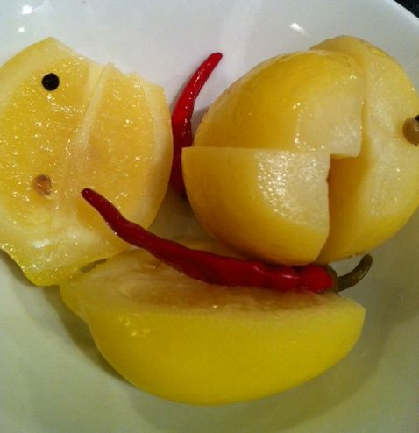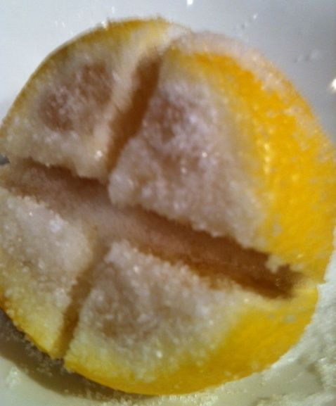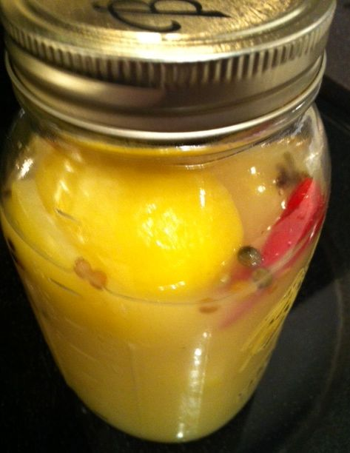
Many North-African recipes call for lemons that have been pickled in salt and their own juices. It's easy to do, but it takes at least 3 weeks before they’re ready to use.

INGREDIENTS:
1 sterilized, quart canning jar
3 - 4 small, Meyer lemons* per canning jar, scrubbed very clean
¼ cup salt, more if needed
lemon juice - up to 32 oz.

Preparation:
1. Place 2 tablespoons of salt in the bottom of a sterilized jar.

2. One by one, prepare the lemons by cutting off any protruding stems from the lemons, and then cutting ¼ inch off one of the tips of each lemon. Cut the lemons as if you were going to cut them in half lengthwise, starting from the tip, but do not cut all the way. Keep the lemon attached at the base. Make another cut in a similar manner, so now the lemon is quartered, but again, attached at the base.

3. Pry the lemons open and generously sprinkle salt all over the insides and outsides of the lemons.

4. Pack as many lemons as you can in the jar, squishing them down so that some juice is extracted. Fill up the jar with lemon juice, making sure the top is covered with juice. Top with a couple more tablespoons of salt.

Note: You can add herbs & spices to the lemons for preserving – I throw in a few cloves, coriander seeds, peppercorns, a couple whole chilies, a cinnamon stick and a bay leaf!

5. Seal the jar tightly and let sit at room temperature until it’s cool enough to place in the refrigerator. Put in refrigerator and let sit, turning upside down occasionally, for at least 3 weeks, until lemon rinds soften.

6. To use, remove a lemon from the jar and rinse thoroughly in water to remove salt. Discard seeds before using. The rinds should be soft enough to eat after 3 weeks.

* You don't need to use Meyer lemons. It’s just that they are purported to be a milder type of lemon, but I’ve found that every-day lemons sold in American supermarkets work very well for preserving in this way.

